**AP LAB MST ASSIGNMENT**

**Aliza Asif**

**22BCS50175**

**FL IOT 601 ‘A’**

1. [**Set Matrix Zeroes**](https://leetcode.com/problems/set-matrix-zeroes/)

class Solution {

 public:

  void setZeroes(vector<vector<int>>& matrix) {

    const int m = matrix.size();

    const int n = matrix[0].size();

    bool shouldFillFirstRow = false;

    bool shouldFillFirstCol = false;

    for (int j = 0; j < n; ++j)

      if (matrix[0][j] == 0) {

        shouldFillFirstRow = true;

        break;

      }

    for (int i = 0; i < m; ++i)

      if (matrix[i][0] == 0) {

        shouldFillFirstCol = true;

        break;

      }

    for (int i = 1; i < m; ++i)

      for (int j = 1; j < n; ++j)

        if (matrix[i][j] == 0) {

          matrix[i][0] = 0;

          matrix[0][j] = 0;

        }

    for (int i = 1; i < m; ++i)

      for (int j = 1; j < n; ++j)

        if (matrix[i][0] == 0 || matrix[0][j] == 0)

          matrix[i][j] = 0;

    if (shouldFillFirstRow)

      for (int j = 0; j < n; ++j)

        matrix[0][j] = 0;

    if (shouldFillFirstCol)

      for (int i = 0; i < m; ++i)

        matrix[i][0] = 0;

  }

};

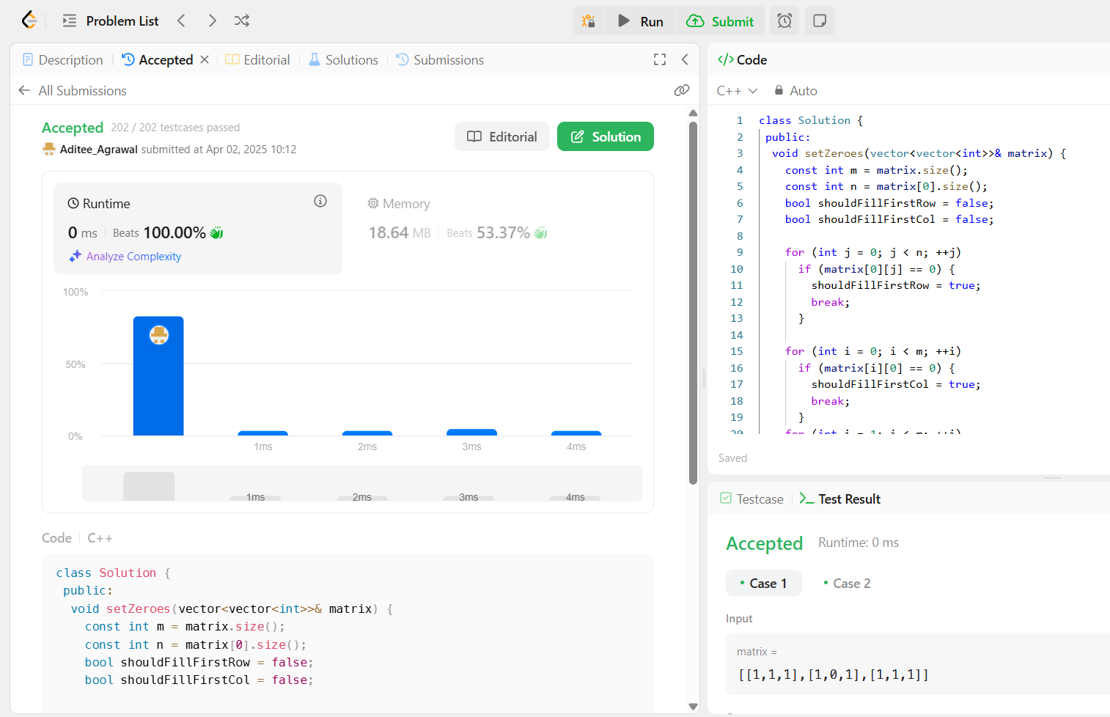

1. [**Longest Substring Without Repeating Characters**](https://leetcode.com/problems/longest-substring-without-repeating-characters/)

class Solution {

public:

int lengthOfLongestSubstring(string s) {

int ans = 0;

vector<int> count(128);

for (int l = 0, r = 0; r < s.length(); ++r) {

++count[s[r]];

while (count[s[r]] > 1)

--count[s[l++]];

ans = max(ans, r - l + 1);

}

return ans;

}

};



1. [**Reverse Linked List II**](https://leetcode.com/problems/reverse-linked-list-ii/)

class Solution {

public:

ListNode* reverseBetween(ListNode* head, int left, int right) {

if (left == 1)

return reverseN(head, right);

head->next = reverseBetween(head->next, left - 1, right - 1);

return head;

}

private:

ListNode* reverseN(ListNode* head, int n) {

if (n == 1)

return head;

ListNode* newHead = reverseN(head->next, n - 1);

ListNode* headNext = head->next;

head->next = headNext->next;

headNext->next = head;

return newHead;

}

};

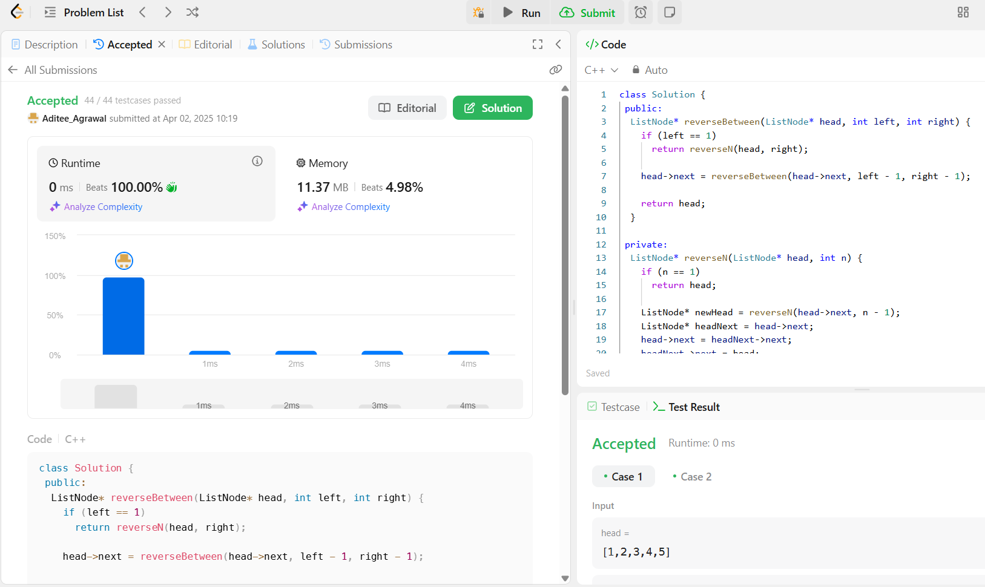

1. [**Linked List Cycle**](https://leetcode.com/problems/linked-list-cycle/)

class Solution {

public:

bool hasCycle(ListNode* head) {

ListNode* slow = head;

ListNode* fast = head;

while (fast != nullptr && fast->next != nullptr) {

slow = slow->next;

fast = fast->next->next;

if (slow == fast)

return true;

}

return false;

}

};

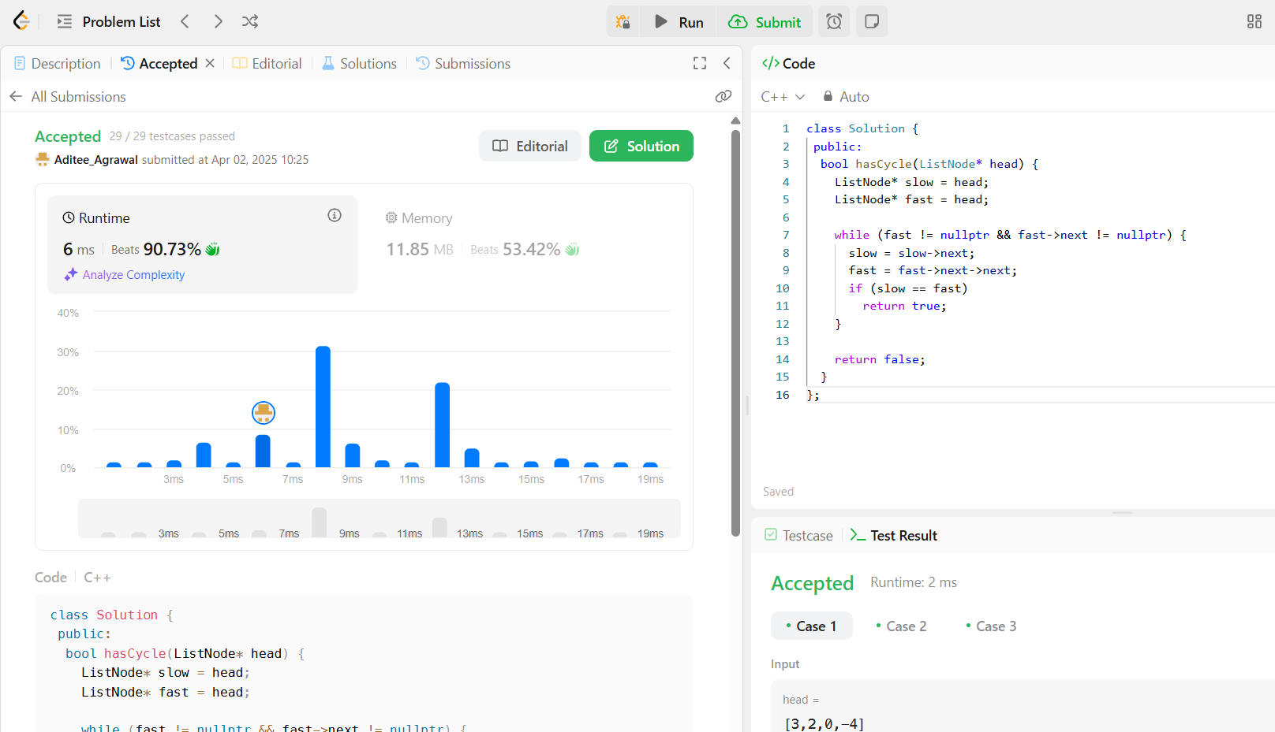

1. [**The Skyline Problem**](https://leetcode.com/problems/the-skyline-problem/)

class Solution {

 public:

  vector<vector<int>> getSkyline(const vector<vector<int>>& buildings) {

    const int n = buildings.size();

    if (n == 0)

      return {};

    if (n == 1) {

      const int left = buildings[0][0];

      const int right = buildings[0][1];

      const int height = buildings[0][2];

      return {{left, height}, {right, 0}};

    }

    const vector<vector<int>> left =

        getSkyline({buildings.begin(), buildings.begin() + n / 2});

    const vector<vector<int>> right =

        getSkyline({buildings.begin() + n / 2, buildings.end()});

    return merge(left, right);

  }

 private:

  vector<vector<int>> merge(const vector<vector<int>>& left,

                            const vector<vector<int>>& right) {

    vector<vector<int>> ans;

    int i = 0;

    int j = 0;

    int leftY = 0;

    int rightY = 0;

    while (i < left.size() && j < right.size())

      if (left[i][0] < right[j][0]) {

        leftY = left[i][1];

        addPoint(ans, left[i][0], max(left[i++][1], rightY));

      } else {

        rightY = right[j][1];

        addPoint(ans, right[j][0], max(right[j++][1], leftY));

      }

    while (i < left.size())

      addPoint(ans, left[i][0], left[i++][1]);

    while (j < right.size())

      addPoint(ans, right[j][0], right[j++][1]);

    return ans;

  }

  void addPoint(vector<vector<int>>& ans, int x, int y) {

    if (!ans.empty() && ans.back()[0] == x) {

      ans.back()[1] = y;

      return;

    }

    if (!ans.empty() && ans.back()[1] == y)

      return;

    ans.push_back({x, y});

  }

};

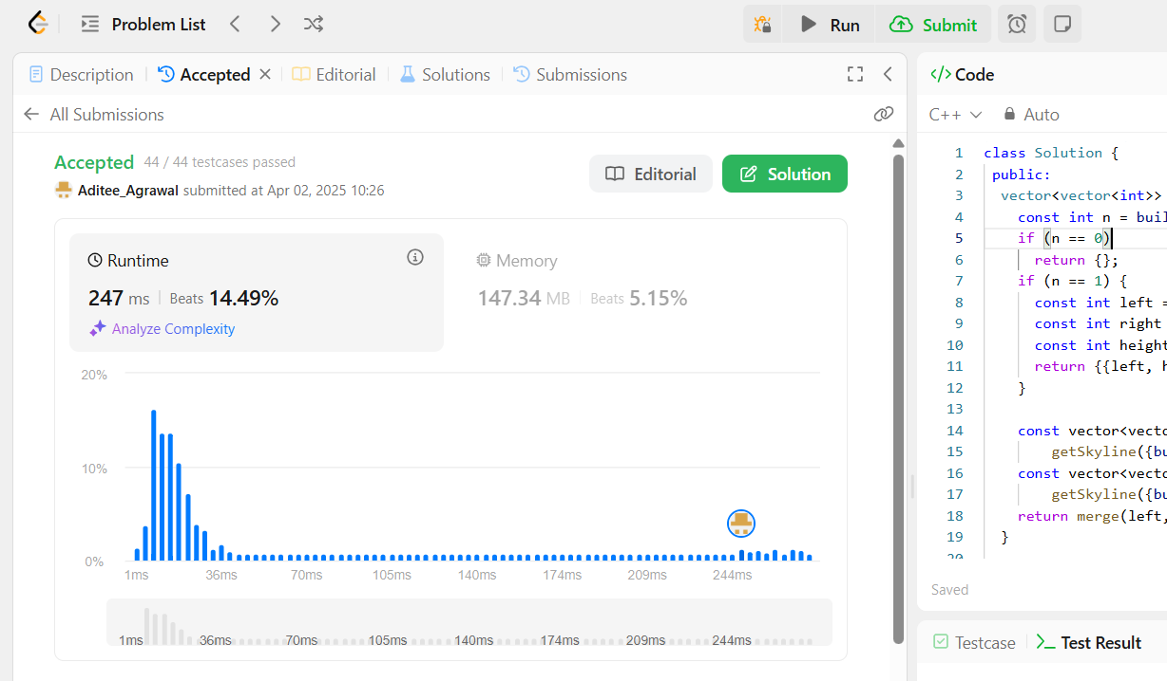

1. [**Longest Increasing Subsequence II**](https://leetcode.com/problems/longest-increasing-subsequence-ii/)

struct SegmentTreeNode {

  int lo;

  int hi;

  int maxLength;

  std::unique_ptr<SegmentTreeNode> left;

  std::unique_ptr<SegmentTreeNode> right;

  SegmentTreeNode(int lo, int hi, int maxLength,

                  std::unique_ptr<SegmentTreeNode> left = nullptr,

                  std::unique_ptr<SegmentTreeNode> right = nullptr)

      : lo(lo),

        hi(hi),

        maxLength(maxLength),

        left(std::move(left)),

        right(std::move(right)) {}

};

class SegmentTree {

 public:

  explicit SegmentTree() : root(make_unique<SegmentTreeNode>(0, 1e5 + 1, 0)) {}

  void updateRange(int i, int j, int maxLength) {

    update(root, i, j, maxLength);

  }

  int queryRange(int i, int j) {

    return query(root, i, j);

  }

 private:

  std::unique_ptr<SegmentTreeNode> root;

  void update(std::unique_ptr<SegmentTreeNode>& root, int i, int j,

              int maxLength) {

    if (root->lo == i && root->hi == j) {

      root->maxLength = maxLength;

      root->left = nullptr;

      root->right = nullptr;

      return;

    }

    const int mid = root->lo + (root->hi - root->lo) / 2;

    if (root->left == nullptr) {

      root->left = make_unique<SegmentTreeNode>(root->lo, mid, root->maxLength);

      root->right =

          make_unique<SegmentTreeNode>(mid + 1, root->hi, root->maxLength);

    }

    if (j <= mid)

      update(root->left, i, j, maxLength);

    else if (i > mid)

      update(root->right, i, j, maxLength);

    else {

      update(root->left, i, mid, maxLength);

      update(root->right, mid + 1, j, maxLength);

    }

    root->maxLength = merge(root->left->maxLength, root->right->maxLength);

  }

  int query(std::unique_ptr<SegmentTreeNode>& root, int i, int j) {

    if (root->left == nullptr)

      return root->maxLength;

    if (root->lo == i && root->hi == j)

      return root->maxLength;

    const int mid = root->lo + (root->hi - root->lo) / 2;

    if (j <= mid)

      return query(root->left, i, j);

    if (i > mid)

      return query(root->right, i, j);

    return merge(query(root->left, i, mid), query(root->right, mid + 1, j));

  }

  int merge(int left, int right) const {

    return max(left, right);

  };

};

class Solution {

 public:

  int lengthOfLIS(vector<int>& nums, int k) {

    int ans = 1;

    SegmentTree tree;

    for (const int num : nums) {

      const int left = max(1, num - k);

      const int right = num - 1;

      const int maxLength = tree.queryRange(left, right) + 1;

      ans = max(ans, maxLength);

      tree.updateRange(num, num, maxLength);

    }

    return ans;

  }

};

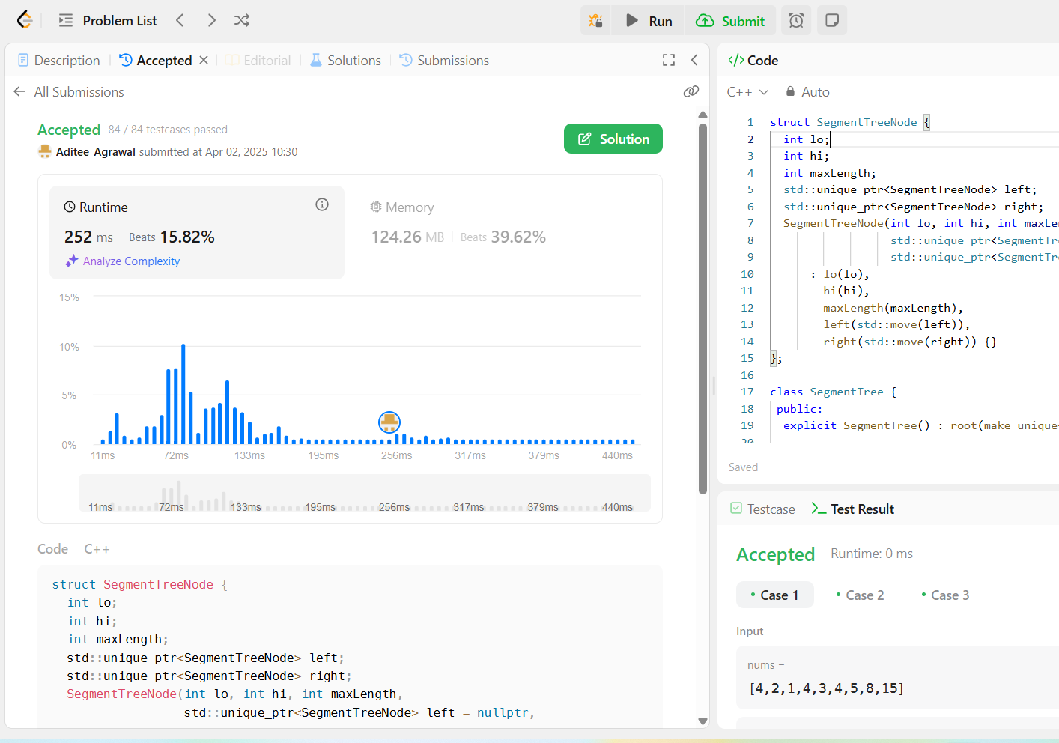

1. [**Search a 2D Matrix II**](https://leetcode.com/problems/search-a-2d-matrix-ii/)

class Solution {

public:

bool searchMatrix(vector<vector<int>>& matrix, int target) {

int r = 0;

int c = matrix[0].size() - 1;

while (r < matrix.size() && c >= 0) {

if (matrix[r][c] == target)

return true;

if (matrix[r][c] > target)

--c;

else

++r;

}

return false;

}

};

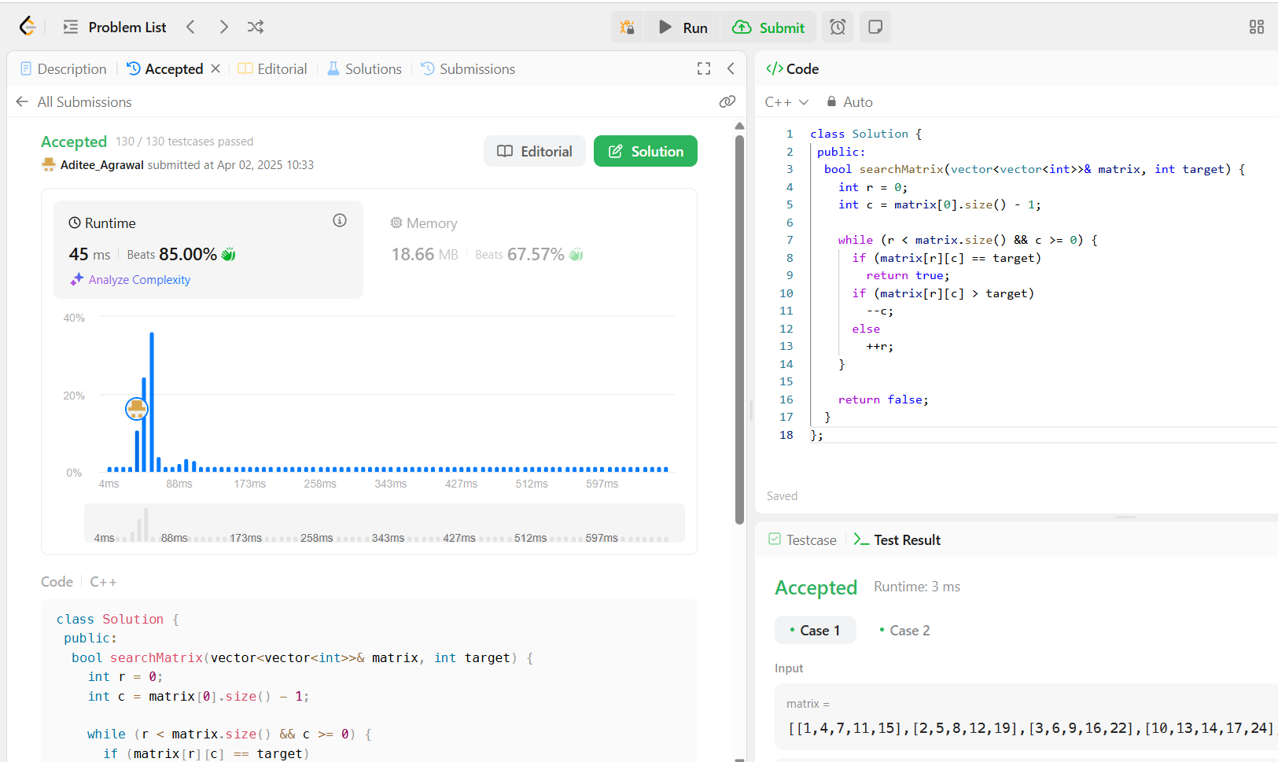

1. [**Word Break**](https://leetcode.com/problems/word-break/)

class Solution {

 public:

  bool wordBreak(string s, vector<string>& wordDict) {

    return wordBreak(s, {wordDict.begin(), wordDict.end()}, {});

  }

 private:

  bool wordBreak(const string& s, const unordered_set<string>&& wordSet,

                 unordered_map<string, bool>&& mem) {

    if (wordSet.contains(s))

      return true;

    if (const auto it = mem.find(s); it != mem.cend())

      return it->second;

    for (int i = 1; i < s.length(); ++i) {

      const string& prefix = s.substr(0, i);

      const string& suffix = s.substr(i);

      if (wordSet.contains(prefix) &&

          wordBreak(suffix, std::move(wordSet), std::move(mem)))

        return mem[s] = true;

    }

    return mem[s] = false;

  }

};

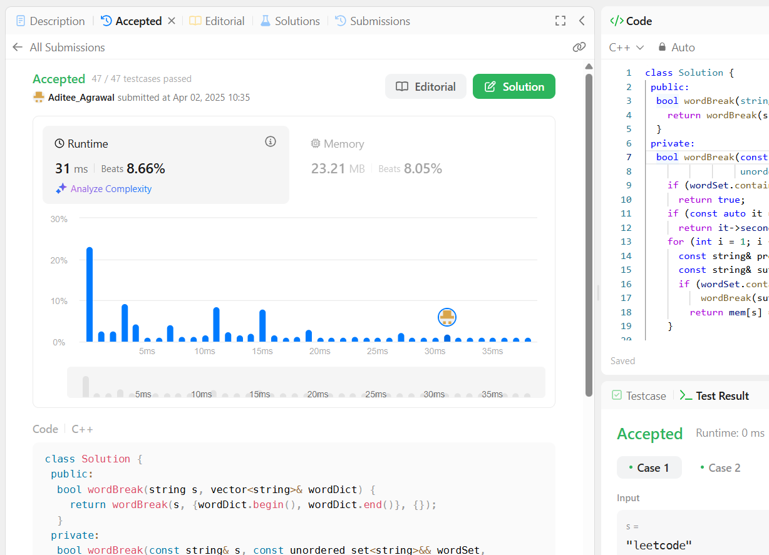

1. [**Longest Increasing Path in a Matrix**](https://leetcode.com/problems/longest-increasing-path-in-a-matrix/)

class Solution {

 public:

  int longestIncreasingPath(vector<vector<int>>& matrix) {

    const int m = matrix.size();

    const int n = matrix[0].size();

    int ans = 0;

    vector<vector<int>> mem(m, vector<int>(n));

    for (int i = 0; i < m; ++i)

      for (int j = 0; j < n; ++j)

        ans = max(ans, dfs(matrix, i, j, INT_MIN, mem));

    return ans;

  }

 private:

  int dfs(const vector<vector<int>>& matrix, int i, int j, int prev,

          vector<vector<int>>& mem) {

    if (i < 0 || i == matrix.size() || j < 0 || j == matrix[0].size())

      return 0;

    if (matrix[i][j] <= prev)

      return 0;

    int& ans = mem[i][j];

    if (ans > 0)

      return ans;

    const int curr = matrix[i][j];

    return ans = 1 + max({dfs(matrix, i + 1, j, curr, mem),

                          dfs(matrix, i - 1, j, curr, mem),

                          dfs(matrix, i, j + 1, curr, mem),

                          dfs(matrix, i, j - 1, curr, mem)});

  }

};

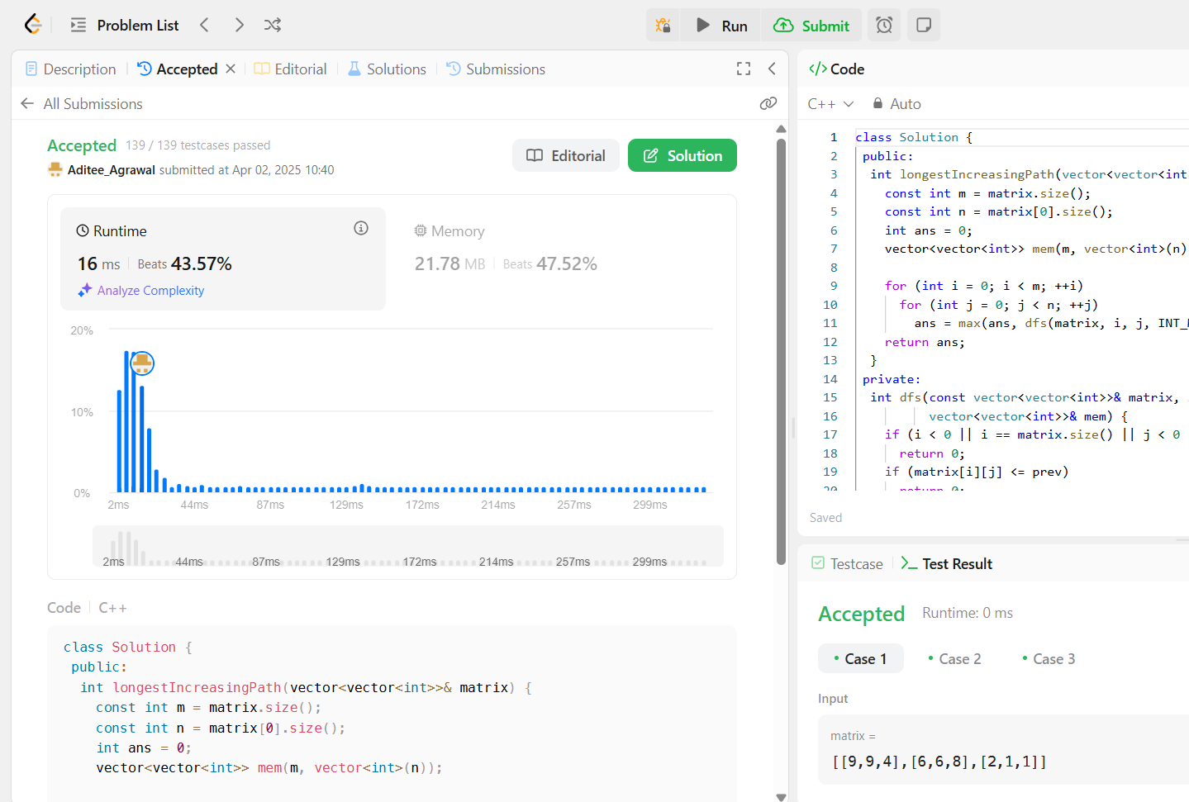

1. [**Trapping Rain Water**](https://leetcode.com/problems/trapping-rain-water/)

class Solution {

 public:

  int trap(vector<int>& height) {

    const int n = height.size();

    int ans = 0;

    vector<int> l(n);

    vector<int> r(n);

    for (int i = 0; i < n; ++i)

      l[i] = i == 0 ? height[i] : max(height[i], l[i - 1]);

    for (int i = n - 1; i >= 0; --i)

      r[i] = i == n - 1 ? height[i] : max(height[i], r[i + 1]);

    for (int i = 0; i < n; ++i)

      ans += min(l[i], r[i]) - height[i];

    return ans;

  }

};

